10-22-15
Hello Parents! We will not be starting a new unit in Reading, Spelling, or Grammar next week. I will not be sending home the weekly fridge sheet. We will mainly be working on Math, Social Studies, Writing, and some fun Pumpkin/Fall/Halloween activities☺.
Please continue to study for our Social Studies Test and practice Math Facts

Monday - "Sporting Good Health" - Wear your favorite sports' team attire

Tuesday - "Knock the Cap off Drugs" - Wear your favorite hat
Chapter 3 Math Test

Wednesday- "Put Drugs to Sleep" - Wear pajamas
Unit 2 Social Studies Test
Please continue to study vocabulary words and address for the test!
*Fall Party 1:30-2:30* - Brittany Cook and Tera Shelton have organized the party!!

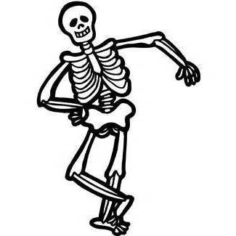
Thursday- "Knock the Socks off Drugs" - Wear silly socks
Early Dismissal-12:30
P/T Conferences- 3:30-7:30

FRIDAY (No School)- P/T Conferences 8:00-12:00

Hope to see you at conferences! Have a great week!
Mrs. Rinehart☺
